Gene Expression Data Analysis and Visualization in RStudio, Libraries:

library(edgeR)

biocLite (GEOquery)

library(GEOquery)

library(Biobase)

library(plyr)

library(gplots)

library(limma)

library(impute)

library(fpc)

library(gplots)

library(Biobase)

library(annotate)

library(multtest)

library(MASS)

library(lda)

library(EMV)

Library(grepl)

library(gdata)

library(matrixStats)

library(plyr) library(class)

library(kernlab)

GSE_data <- read.delim("~/Documents/FinalHW/GSE174443_gene_counts_matrix_with_Blanks.txt", row.names=1,header=T)

dim(GSE_data)

[1] **27744** 24

**#Reorder the Columns in the File**

GSEreorder <- GSE_data[, order(names(GSE_data))]

dim(GSEreorder)

[1] 27744 24

colnames(GSEreorder)

[1] "Control_011" "Control_013" "Control_018" "Control_022" "Control_024"

[6] "Control_027" "Control_031" "Sarcoidosis_001" "Sarcoidosis_005" "Sarcoidosis_007"

[11] "Sarcoidosis_014" "Sarcoidosis_017" "Sarcoidosis_020" "Sarcoidosis_023" "Sarcoidosis_026"

[16] "Sarcoidosis_029" "Sarcoidosis_032" "TB_006" "TB_008" "TB_012"

[21] "TB_015" "TB_021" "TB_025" "TB_030"

View(GSEreorder)

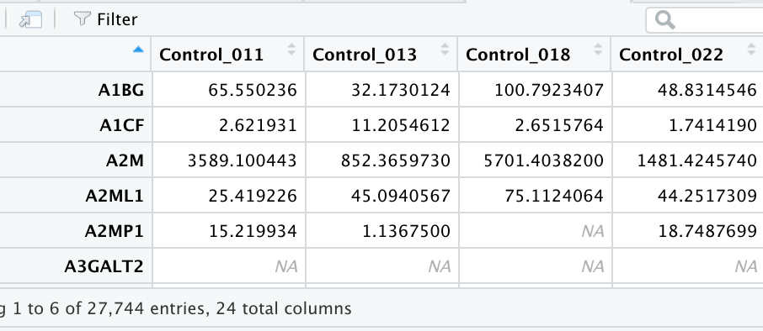

1. First, we test for **outlier samples** and provide visual proof.

**#Average Correlation Plot**

dat.cor <- cor(GSEreorder, use="pairwise.complete.obs")

dat.cor

dat.avg <- apply(dat.cor,1,mean)

par(oma=c(6,0.1,0.1,0.1))

plot(c(1,length(dat.avg)),range(dat.avg),type="n",xlab="",ylab="Avg R",main="Average Correlation of SC, TB, and Normal Samples",axes=F)

points(dat.avg,bg="red",col=1,pch=21,cex=1.5)

axis(1,at=c(1:length(dat.avg)),labels=dimnames(GSEreorder)[[2]],las=2,cex=0.5)

axis(2)

abline(v=seq(0.5,25,1),col="grey")



**#Hierarchical Clustering Dendrogram**

dat.t <- t(GSEreorder)

dat.dist <- dist(dat.t, method="euclidean")

dat.clust <- hclust(dat.dist,method="single")

plot(hclust(dat.dist), labels=dimnames(GSEreorder)[[2]],main="Hierarchical Clustering Dendrogram of SC, TB, and Normal Samples",cex.main=0.75)



**#CV vs. Mean Plot**

dat.mean <- apply(GSEreorder,2,mean, na.rm=TRUE)

dat.sd <- apply(GSEreorder,2,sd, na.rm=TRUE)

dat.cv <- dat.sd/dat.mean

plot(dat.mean,dat.cv,main="Coefficient Correlation vs Mean\n for SC, TB, and Normal Samples",xlab="Mean",ylab="CV",col="blue",cex=1.5,type="n")

points(dat.mean,dat.cv,bg="lightblue",col=1,pch=21)

text(dat.mean,dat.cv,label=dimnames(GSEreorder)[[2]],pos=1,cex=0.5)



**#Correlation Plot (Heatmap)**

dat.cor <- cor(GSEreorder, use="pairwise.complete.obs")

dat.cor

layout(matrix(c(1,1,1,1,1,1,1,1,2,2), 5, 2, byrow = TRUE))

**par**(oma=c(2,2,1,1))

cx<- rev(colorpanel(25,"blue", "white", "red"))

leg <- seq(min(dat.cor,na.rm=T),max(dat.cor,na.rm=T),length=10)

image(dat.cor,main="Correlation Matrix Heatmap of SC, TB, and Normal Samples", axes=F, col=cx)

axis(1,at=seq(0,1,length=ncol(dat.cor)),label=dimnames(dat.cor)[[2]], cex.axis=0.9, las=2)

axis(2,at=seq(0,1,length=ncol(dat.cor)),label=dimnames(dat.cor)[[2]], cex.axis=0.9, las=2)

image(as.matrix(leg),col=cx, axes=F)

tmp <- round(leg,2)

axis(1,at=seq(0,1,length=length(leg)),labels=tmp,cex.axis=1)

see presentation

Remove these outliers.

dim(GSEreorder)

[1] 27744 24

colnames(GSEreorder)

[1] "Control_011" "Control_013" "Control_018" "Control_022" "Control_024"

[6] "Control_027" "Control_031" "Sarcoidosis_001" "Sarcoidosis_005" "Sarcoidosis_007"

[11] "Sarcoidosis_014" "Sarcoidosis_017" "Sarcoidosis_020" "Sarcoidosis_023" "Sarcoidosis_026"

[16] "Sarcoidosis_029" "Sarcoidosis_032" "TB_006" "TB_008" "TB_012"

[21] "TB_015" "TB_021" "TB_025" "TB_030"

Sample Control_013 is the outlier sample.

**#Remove Outlier Control_13**

**datout** <- GSEreorder[, !(colnames(GSEreorder) %in% c("Control_013"))]

dim(datout)

[1] 27744 23

colnames(datout)

[1] "Control_011" "Control_018" "Control_022" "Control_024" "Control_027"

[6] "Control_031" "Sarcoidosis_001" "Sarcoidosis_005" "Sarcoidosis_007" "Sarcoidosis_014"

[11] "Sarcoidosis_017" "Sarcoidosis_020" "Sarcoidosis_023" "Sarcoidosis_026" "Sarcoidosis_029"

[16] "Sarcoidosis_032" "TB_006" "TB_008" "TB_012" "TB_015"

[21] "TB_021" "TB_025" "TB_030"

Log2 transform the data and filter out transcripts that have **low expression** values or missing.

**#Log2 Transform the Data**

datout.log <- log2(datout)

dim(datout.log)

[1] 27744 23

**#Remove Missing Values (NAs, Blanks, 0) from the log2 transformed data**

datout.log.No.NA <- na.omit(datout.log)

dim(datout.log.No.NA)

[1] 10331 23

Output: Dataset is now composed of 23 samples and 10331 transcripts.

Method of feature selection with a statistical test. For two conditions comparisons, a two-sample test is used, for three group comparison conditions - ANOVA tests is used.

**#ANOVA (Analysis of Variance, p-value reported)**

aov.all.genes <- function(x,s1,s2,s3) {

x1 <- as.numeric(x[s1])

x2 <- as.numeric(x[s2])

x3 <- as.numeric(x[s3])

fac <- c(rep("A",length(x1)), rep("B",length(x2)), rep("C",length(x3)))

a.dat <- data.frame(as.factor(fac),c(x1,x2,x3))

names(a.dat) <- c("factor","express")

p.out <- summary(aov(express~factor, a.dat))[[1]][1,5]

return(p.out) }

aov.run <- apply(datout.log.No.NA,1, aov.all.genes,s1=c(1:6),s2=c(7:16),s3=c(17:23))

aov.run

**#Number of Statistically Significant Transcripts at different p-value thresholds**

sum(aov.run<.05)

[1] 1846

sum(aov.run<.01)

[1] 683

sum(aov.run<(.05/10331))

[1] 20

**#Obtain the List of Transcripts with P-value < 0.05**

pv <-as.data.frame(aov.run)

pvA <- subset(pv, pv<0.05)

pvA

dim(pvA)

[1] 1846

**#ANOVA (F-statistic reported)**

**#this is an Extra Code**

aov.all.genes <- function(x,s1,s2,s3) {

x1 <- as.numeric(x[s1])

x2 <- as.numeric(x[s2])

x3 <- as.numeric(x[s3])

fac <- c(rep("A",length(x1)), rep("B",length(x2)), rep("C",length(x3)))

a.dat <- data.frame(as.factor(fac),c(x1,x2,x3))

names(a.dat) <- c("factor","express")

p.outF <- summary(aov(express~factor, a.dat))[[1]][1,4]

return(p.outF)

}

aov.runF <- apply(datout.log.No.NA,1, aov.all.genes,s1=c(1:6),s2=c(7:16),s3=c(17:23))

aov.runF

Adjust for multiplicity.

**#Multiple testing correction procedures: Holm and Bonferroni.**

**#Holm Multiple Testing Correction Method.**

aov.run.holm <- p.adjust(aov.run, method="holm")

aov.run.holm

sum(aov.run.holm<.05)

[1] 20

pvh <-as.data.frame(aov.run.holm)

pvH <- subset(pvh, pvh<0.05)

pvH

aov.run.holm

ALAS1 2.700519e-02

C15orf48 1.361710e-05

C7 8.518631e-03

CCL21 6.379488e-04

CHI3L1 5.786055e-06

CLEC4E 3.988156e-02

CXCL9 1.340064e-02

CYP27B1 4.673795e-03

DNAJC5B 1.330780e-02

DSP 1.337230e-03

FCGR2A 6.095653e-03

FTH1 1.301722e-02

FTH1P11 1.387408e-02

FTH1P2 3.384643e-03

FTH1P23 4.031312e-03

GBP1 7.403439e-03

MYOF 5.184531e-03

SNX10 1.877543e-03

TFEC 2.592348e-03

TLR8 2.877153e-03

**#Subset Data With statistically significant Transcripts from the Holm Test.**

datout.log.No.NA.sub.Holm <- datout.log.No.NA[rownames(pvH),]

dim(datout.log.No.NA.sub.Holm)

[1] 20 23

datout.log.No.NA.sub.Holm

summary(datout.log.No.NA.sub.Holm)

**#Bonferroni Multiple Testing Correction Method.**

aov.run.bonferroni <- p.adjust(aov.run, method="bonferroni")

aov.run.bonferroni

sum(aov.run.bonferroni<.05)

[1] 20

pvb <-as.data.frame(aov.run.bonferroni)

pvB <- subset(pvb, pvb<0.05)

pvB

aov.run.bonferroni

ALAS1 2.705232e-02

C15orf48 1.361842e-05

C7 8.529364e-03

CCL21 6.380724e-04

CHI3L1 5.786055e-06

CLEC4E 3.995504e-02

CXCL9 1.342143e-02

CYP27B1 4.677870e-03

DNAJC5B 1.332715e-02

DSP 1.337618e-03

FCGR2A 6.102150e-03

FTH1 1.303489e-02

FTH1P11 1.389695e-02

FTH1P2 3.386938e-03

FTH1P23 4.034436e-03

GBP1 7.412049e-03

MYOF 5.189554e-03

SNX10 1.878271e-03

TFEC 2.593603e-03

TLR8 2.878825e-03

**#Subset Data with statistically significant Transcripts from the Bonferroni Test**

datout.log.No.NA.sub.Bonferroni <- datout.log.No.NA[rownames(pvB),]

dim(datout.log.No.NA.sub.Bonferroni)

[1] 20 23

#See the final table in the power point presentation.

Provide the number of genes retained with the associated score (p-value, weight, test statistic, etc.) and threshold value that is used.

**1846** transcripts are identified to be significantly differently expressed with p-value < 0.05 threshold; and **683** - with p-value threshold < 0.01.

When Holm’s multiple testing correction method was applied, **20** genes were found to be statistically significant at p < 0.5 threshold.

When Bonferroni’s multiple testing correction method was applied, **20** genes were found to be statistically significant at p < 0.5 threshold.

**#Calculate Mean Gene Expression of Transcripts for 3 Groups:**

**#Subset Data with statistically significant genes from Holm Test.**

datout.log.No.NA.sub.Holm <- datout.log.No.NA[rownames(pvH),]

dim(datout.log.No.NA.sub.Holm)

[1] 20 23

View(datout.log.No.NA.sub.Holm)

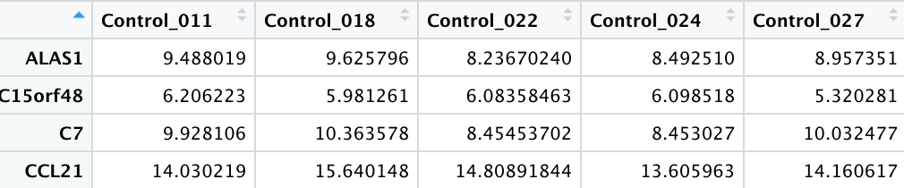

datout.log.No.NA.sub.HolmC <- datout.log.No.NA[rownames(pvH),c(1:6)]

datout.log.No.NA.sub.HolmC.t <-t(datout.log.No.NA.sub.HolmC)

summary(datout.log.No.NA.sub.HolmC.t)

**ALAS1 C15orf48 C7 CCL21 CHI3L1**

Min. :8.237 Min. :5.320 Min. : 8.453 Min. :13.61 Min. :5.763

1st Qu.:8.495 1st Qu.:6.007 1st Qu.: 8.718 1st Qu.:13.88 1st Qu.:7.062

Median :8.730 Median :6.091 Median : 9.718 Median :14.10 Median :7.740

Mean :8.884 Mean :5.980 Mean : 9.457 Mean :14.35 Mean :7.550

3rd Qu.:9.355 3rd Qu.:6.166 3rd Qu.:10.006 3rd Qu.:14.65 3rd Qu.:8.000

Max. :9.626 Max. :6.206 Max. :10.364 Max. :15.64 Max. :9.133

**CLEC4E CXCL9 CYP27B1 DNAJC5B DSP**

Min. :2.976 Min. : 8.310 Min. :-0.02046 Min. :3.722 Min. :6.733

1st Qu.:5.156 1st Qu.: 8.675 1st Qu.: 4.09254 1st Qu.:3.880 1st Qu.:7.757

Median :6.799 Median : 9.438 Median : 5.39302 Median :4.548 Median :8.068

Mean :6.493 Mean : 9.282 Mean : 4.31897 Mean :4.847 Mean :8.034

3rd Qu.:7.722 3rd Qu.: 9.505 3rd Qu.: 5.51309 3rd Qu.:5.331 3rd Qu.:8.310

Max. :9.750 Max. :10.558 Max. : 5.93610 Max. :7.016 Max. :9.291

**FCGR2A FTH1 FTH1P11 FTH1P2 FTH1P23**

Min. :5.501 Min. :15.01 Min. :4.942 Min. :5.170 Min. :3.641

1st Qu.:6.060 1st Qu.:15.19 1st Qu.:5.700 1st Qu.:5.310 1st Qu.:4.010

Median :7.014 Median :15.50 Median :6.099 Median :5.736 Median :4.675

Mean :6.824 Mean :15.57 Mean :6.061 Mean :5.726 Mean :4.503

3rd Qu.:7.635 3rd Qu.:15.71 3rd Qu.:6.624 3rd Qu.:5.878 3rd Qu.:4.939

Max. :7.829 Max. :16.52 Max. :6.860 Max. :6.621 Max. :5.211

**GBP1 MYOF SNX10 TFEC TLR8**

Min. : 9.288 Min. :7.732 Min. :4.145 Min. :6.379 Min. :5.637

1st Qu.: 9.314 1st Qu.:8.053 1st Qu.:4.370 1st Qu.:6.645 1st Qu.:5.830

Median : 9.363 Median :8.364 Median :4.416 Median :7.084 Median :6.194

Mean : 9.522 Mean :8.346 Mean :4.495 Mean :7.248 Mean :6.124

3rd Qu.: 9.404 3rd Qu.:8.493 3rd Qu.:4.531 3rd Qu.:7.616 3rd Qu.:6.330

Max. :10.405 Max. :9.128 Max. :5.068 Max. :8.648 Max. :6.637

datout.log.No.NA.sub.HolmS <- datout.log.No.NA[rownames(pvH),c(7:16)]

datout.log.No.NA.sub.HolmS.t <-t(datout.log.No.NA.sub.HolmS)

summary(datout.log.No.NA.sub.HolmS.t)

**ALAS1 C15orf48 C7 CCL21 CHI3L1**

Min. :10.14 Min. :10.39 Min. : 6.877 Min. :11.01 Min. :12.57

1st Qu.:11.14 1st Qu.:10.56 1st Qu.: 7.950 1st Qu.:12.29 1st Qu.:14.06

Median :11.58 Median :11.97 Median : 8.297 Median :12.71 Median :14.38

Mean :11.50 Mean :11.63 Mean : 8.425 Mean :12.55 Mean :14.18

3rd Qu.:12.05 3rd Qu.:12.42 3rd Qu.: 8.916 3rd Qu.:13.11 3rd Qu.:14.55

Max. :12.43 Max. :12.75 Max. :10.192 Max. :13.80 Max. :14.83

**CLEC4E CXCL9 CYP27B1 DNAJC5B DSP**

Min. :10.22 Min. : 9.963 Min. : 7.888 Min. : 7.573 Min. :4.740

1st Qu.:10.76 1st Qu.:12.439 1st Qu.: 9.163 1st Qu.: 8.860 1st Qu.:5.243

Median :11.16 Median :12.511 Median :10.416 Median : 9.843 Median :5.834

Mean :11.19 Mean :12.540 Mean :10.188 Mean : 9.501 Mean :5.798

3rd Qu.:11.64 3rd Qu.:13.078 3rd Qu.:11.290 3rd Qu.:10.207 3rd Qu.:6.470

Max. :12.46 Max. :13.825 Max. :11.584 Max. :10.265 Max. :6.668

**FCGR2A FTH1 FTH1P11 FTH1P2 FTH1P23**

Min. : 8.859 Min. :17.38 Min. : 8.005 Min. :7.911 Min. :6.758

1st Qu.:10.341 1st Qu.:18.21 1st Qu.: 8.754 1st Qu.:8.279 1st Qu.:7.287

Median :10.685 Median :18.95 Median : 9.142 Median :8.524 Median :7.920

Mean :10.437 Mean :18.77 Mean : 9.192 Mean :8.650 Mean :7.843

3rd Qu.:10.975 3rd Qu.:19.38 3rd Qu.: 9.617 3rd Qu.:9.102 3rd Qu.:8.428

Max. :11.413 Max. :19.86 Max. :10.643 Max. :9.343 Max. :8.854

**GBP1 MYOF SNX10 TFEC TLR8**

Min. :10.43 Min. :10.11 Min. :6.481 Min. : 9.027 Min. : 8.483

1st Qu.:11.52 1st Qu.:10.95 1st Qu.:7.181 1st Qu.: 9.554 1st Qu.: 9.239

Median :11.83 Median :11.66 Median :7.875 Median :10.112 Median : 9.617

Mean :11.91 Mean :11.67 Mean :7.685 Mean : 9.960 Mean : 9.649

3rd Qu.:12.34 3rd Qu.:12.48 3rd Qu.:8.338 3rd Qu.:10.367 3rd Qu.: 9.879

Max. :12.98 Max. :13.17 Max. :8.449 Max. :10.582 Max. :11.508

datout.log.No.NA.sub.HolmT <- datout.log.No.NA[rownames(pvH),c(17:23)]

datout.log.No.NA.sub.HolmT.t <-t(datout.log.No.NA.sub.HolmT)

summary(datout.log.No.NA.sub.HolmT.t)

**ALAS1 C15orf48 C7 CCL21 CHI3L1**

Min. : 9.351 Min. : 9.542 Min. :3.250 Min. : 7.554 Min. :10.97

1st Qu.:10.792 1st Qu.:11.279 1st Qu.:4.258 1st Qu.: 8.519 1st Qu.:12.34

Median :11.037 Median :12.294 Median :5.946 Median : 9.427 Median :13.24

Mean :10.945 Mean :11.990 Mean :5.273 Mean : 9.278 Mean :13.06

3rd Qu.:11.408 3rd Qu.:12.760 3rd Qu.:6.282 3rd Qu.: 9.620 3rd Qu.:13.56

Max. :11.825 Max. :14.015 Max. :6.637 Max. :11.690 Max. :15.40

**CLEC4E CXCL9 CYP27B1 DNAJC5B DSP**

Min. : 9.28 Min. :11.77 Min. : 8.495 Min. :6.119 Min. :2.700

1st Qu.:10.72 1st Qu.:12.83 1st Qu.:10.000 1st Qu.:7.078 1st Qu.:3.807

Median :11.06 Median :13.64 Median :10.849 Median :8.257 Median :4.228

Mean :10.94 Mean :13.46 Mean :10.494 Mean :8.176 Mean :4.137

3rd Qu.:11.33 3rd Qu.:13.88 3rd Qu.:11.031 3rd Qu.:9.487 3rd Qu.:4.397

Max. :12.17 Max. :15.36 Max. :12.055 Max. :9.723 Max. :5.622

**FCGR2A FTH1 FTH1P11 FTH1P2 FTH1P23**

Min. : 8.146 Min. :16.54 Min. :7.054 Min. :6.653 Min. :5.769

1st Qu.:10.154 1st Qu.:17.73 1st Qu.:8.456 1st Qu.:7.560 1st Qu.:6.701

Median :10.297 Median :18.41 Median :8.644 Median :8.588 Median :7.590

Mean :10.214 Mean :18.21 Mean :8.635 Mean :8.212 Mean :7.223

3rd Qu.:10.789 3rd Qu.:18.89 3rd Qu.:8.986 3rd Qu.:8.909 3rd Qu.:7.762

Max. :11.165 Max. :19.32 Max. :9.862 Max. :9.306 Max. :8.276

**GBP1 MYOF SNX10 TFEC TLR8**

Min. :11.26 Min. :10.52 Min. :6.106 Min. : 8.942 Min. : 6.998

1st Qu.:12.37 1st Qu.:11.23 1st Qu.:7.324 1st Qu.: 9.455 1st Qu.: 8.688

Median :13.35 Median :11.72 Median :7.619 Median :10.055 Median : 9.080

Mean :13.06 Mean :11.74 Mean :7.778 Mean : 9.924 Mean : 8.934

3rd Qu.:14.00 3rd Qu.:12.29 3rd Qu.:8.383 3rd Qu.:10.312 3rd Qu.: 9.530

Max. :14.03 Max. :12.91 Max. :9.306 Max. :10.937 Max. :10.021

Plot the scores of those genes retained in a histogram.

**#Histogram for Retained Genes (Holm Test)**

pvh <-as.data.frame(aov.run.holm)

pvH <- subset(pvh, pvh<0.05)

pvH

**#Remove Row Names from the Subset of Genes Identified by Holm’s Test**

dat.f.sub.H <- pvH[rownames(pvH),]



[1] 2.700519e-02 1.361710e-05 8.518631e-03 6.379488e-04 5.786055e-06 3.988156e-02 1.340064e-02

[8] 4.673795e-03 1.330780e-02 1.337230e-03 6.095653e-03 1.301722e-02 1.387408e-02 3.384643e-03

[15] 4.031312e-03 7.403439e-03 5.184531e-03 1.877543e-03 2.592348e-03 2.877153e-03

**par**(oma=c(1,1,1,1))

**hist**(dat.f.sub.H, main="Histogram of 20 Transcripts Identified by the Holm Test",xlab="p-values",col="green")



**#Histogram for Retained Genes (from Bonferroni Test)**

pvb <-as.data.frame(aov.run.bonferroni)

pvB <- subset(pvb, pvb<0.05)

pvB

**#Remove Row Names from the Subset of Genes Identified by Bonferroni’s Test**

dat.f.sub.B <- pvB[rownames(pvB),]

**par**(oma=c(1,1,1,1))

hist(dat.f.sub.B, main="Histogram of Transcripts Identified by the Bonferroni Test",xlab="p-values",col="blue")



**#Histogram for ANOVA p-values for All Expressed Genes (for comparison)**

dat.f.sub.A <- pvA[rownames(pvA),]

hist(dat.f.sub.A, main="Histogram of Transcripts Identified by the ANOVA Test",xlab="p-values",col="yellow")

abline(**v=.01**, col=2, lwd=2)



Subset data by the genes identified above. Perform **clustering** and **dimensionality** reduction methods to visualize the samples in two-dimensional space (xy scatter plot, dendrogram).

**#Obtain the List of Transcripts with P-value < 0.05 from ANOVA on Log2–Transformed Data**

pv<-as.data.frame(aov.run)

pvA <- subset(pv, pv<0.05)

pvA

**#Number of Statistically Significant Transcripts**

sum(aov.run<.05)

[1] 1846

**#Subset Data with Genes That Have P-value < 0.05 from ANOVA, 23 samples.**

datout.log.No.NA.subA <- datout.log.No.NA[rownames(pvA),].

dim(datout.log.No.NA.subA)

[1] 1846 23

View(datout.log.No.NA.subA)

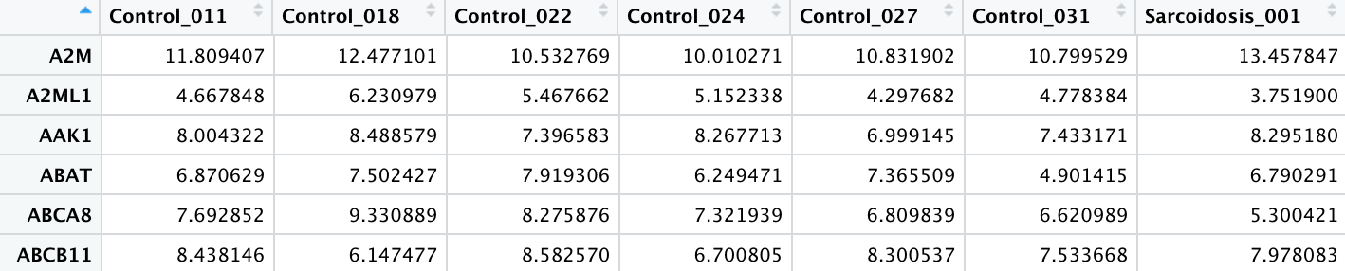

**#Calculate kmeans PCA on the samples and retain the first two component vectors, k=3.**

dat.pca <- prcomp(t(datout.log.No.NA.subA))

dat.loadingsA <- dat.pca$x[,1:2]

View(dat.loadingsA) View(clA)

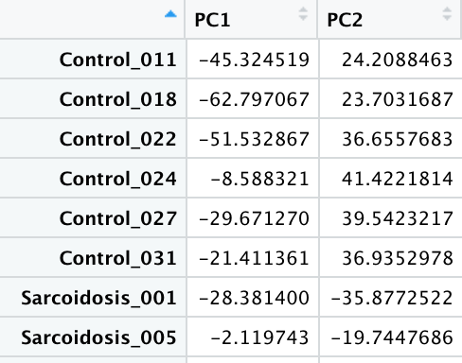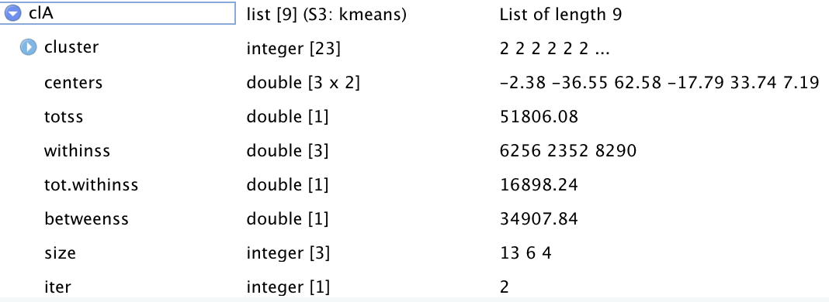

**#Plot K-means Clustering (from ANOVA set)**

groupsA <- factor(substr(names(datout.log.No.NA.subA),1,1))

groupsA

[1] C C C C C C S S S S S S S S S S T T T T T T T

Levels: C S T

**par**(oma=c(1,1,1,1))

**plot**(dat.loadingsA, col=clA$cluster,cex=1, main="PCA Scatter Plot of K-means Classification\n(1,846 Transcripts from the ANOVA Test)", xlab='PC1', ylab='PC2')

points(clA$centers, col =1:3, pch ="*",cex=2.5)

text(dat.loadingsA,labels=groupsA, pos=4)

 *, centroid. PC, Principal Component.

**#Plot a Hierarchical Clustering Dendrogram (from ANOVA set)**

datout.log.No.NA.subA <- datout.log.No.NA[rownames(pvA),]

dim(datout.log.No.NA.subA)

[1] 1846 23

groupsA <- factor(substr(names(datout.log.No.NA.subA),1,1))

**par**(oma=c(1,1,1,1))

**hcA** <- **hclust**(dist(t(datout.log.No.NA.subA), method="manhattan"), "median")

plot(hcA, main="Hierarchical Clustering Dendrogram\n(1,846 Transcripts from the ANOVA Test)", labels=groupsA)



**# Multiple Testing Corrections, MTC (Holm and Bonferroni Tests on Log2–transformed data)**

**#Obtain the List of Transcripts with P-values < 0.05 from Holm Test**

aov.run.holm <- p.adjust(aov.run, method="holm")

aov.run.holm

pvh <-as.data.frame(aov.run.holm)

pvH <- subset(pvh, pvh<0.05)

pvH

**#Number of Statistically Significant Transcripts from Holm Test**

sum(aov.run.holm<.05)

[1] 20

**#Subset Data with Genes That Have P-value < 0.05 from Holm Test**

datout.log.No.NA.sub.Holm <- datout.log.No.NA[rownames(pvH),]

dim(datout.log.No.NA.sub.Holm)

[1] 20 23

**#Calculate PCA on the samples and retain the first two component vectors, k=3**

dat.pca.Holm <- prcomp(t(datout.log.No.NA.sub.Holm))

dat.loadings.Holm <- dat.pca.Holm$x[,1:2]

clH <- **kmeans**(dat.loadings.Holm, centers=3, iter.max=20)

**#Plot K-means PCA Scatter Plot from Holm Test.**

groupsH <- factor(substr(names(datout.log.No.NA.sub.Holm),1,1))

**par**(oma=c(1,1,1,1))

**plot**(dat.loadings.Holm, col = clH$cluster,cex=1, main="PCA Scatter Plot of K-means Classification\n(20 Transcripts from the Holm Test)", xlab='PC1', ylab='PC2')

points(clH$centers, col = 1:3, pch = "*",cex=2.5)

text(dat.loadings.Holm,labels=groupsH, pos=4)



*, centroid

**#Plot a Hierarchical Clustering Dendrogram from Holm Test.**

datout.log.No.NA.Holm <- datout.log.No.NA[rownames(pvH),]

dim(datout.log.No.NA.Holm)

[1] 20 23

groupsH <- factor(substr(names(datout.log.No.NA.sub.Holm),1,1))

**hch** <- **hclust**(dist(t(datout.log.No.NA.Holm), method="manhattan"), "median")

plot(hch, main="Hierarchical Clustering Dendrogram\n(20 Transcripts from the Holm Test)", labels=groupsH)

# (not shown in presentation)

Using linear projections of the original data (i.e. cluster centroids, latent variables), classify the samples into their respective classes.

**#Subset Data with Genes that Have P-value < 0.05 from ANOVA.**

datout.log.No.NA.subA <- datout.log.No.NA[rownames(pvA),]

dim(datout.log.No.NA.subA)

[1] 1846 23

**#Rename rows creating new column and add new header**

**#Create factor groups with 3 levels**

groupsA <- factor(substr(names(datout.log.No.NA.subA),1,1))

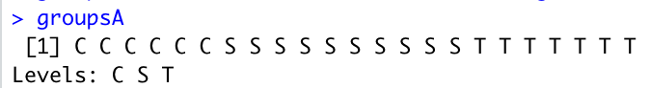

d.groups <- data.frame(groupsA, t(datout.log.No.NA.subA))

dim(d.groups)

[1] 23 1847

View(d.groups)

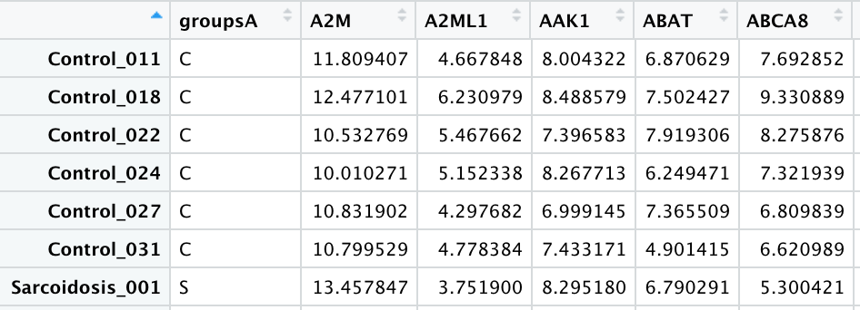

**#Make first row names from column 1.**

rownames(d.groups) <- d.groups[,1]

rownames(d.groups)<-NULL

View(d.groups)

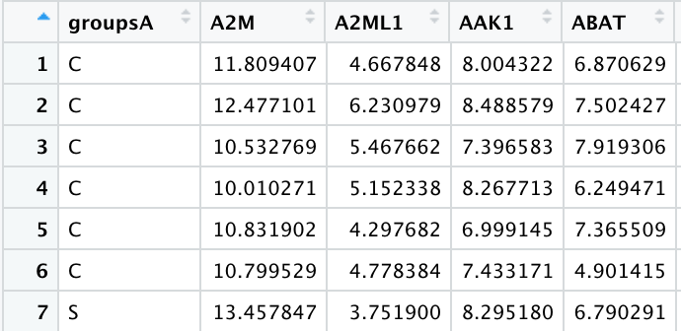

**# Visualization and Comparisons of Train-Test Data via Classification Methods**

**#Linear Discriminant Analysis of original dataset.**

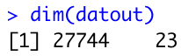

groupsall <- factor(substr(names(datout),1,1))

d.groups.all <- data.frame(groupsall,t(datout))

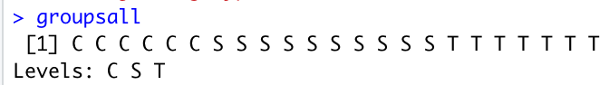

View(d.groups.all)

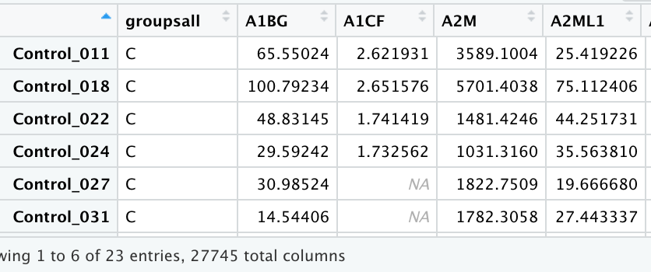

trainall <- d.groups.all[c(1:4,7:13,17:21),]

testall <- d.groups.all[c(5:6,14:16,22:23),]

**output** <- testall[,1]

testall <- testall[,-1]

lda.train.all <- **lda**(groupsall ~ ., data=trainall)

lda.test.all <- predict(lda.train.all, testall)

table(lda.test.all$class, **output**)

**output**

C S T

C 0 0 0

S 2 **2** 2

T 0 1 0

**par**(oma=c(1,1,1,1))

plot(lda.test1$x,col=as.numeric(labs1),cex=1.5,pch=15,main="Linear Discriminant Plot\n(Using 27,744 Transcripts from Original Data)", ylab="LD2", xlab="LD1")

legend(0.4,0.8,pch=15,col= unique(as.numeric(**output**)),unique(as.character(**output**)))

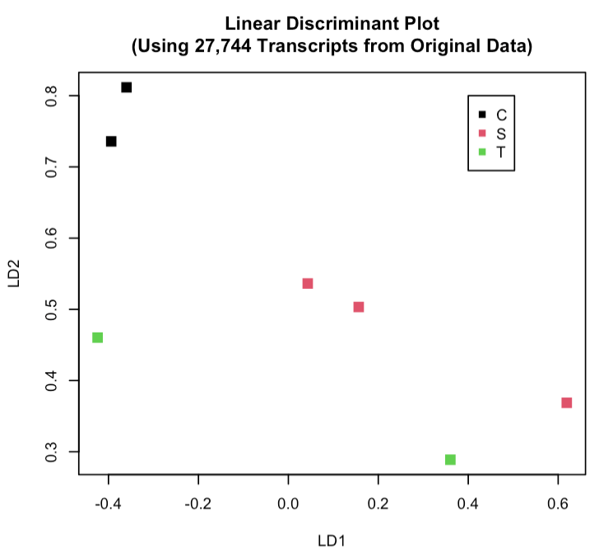Conclusion: 5 test samples got misclassified.

**#Linear Discriminant Analysis on ANOVA (1846 transcripts).**

train <- d.groups[c(1:4,7:13,17:21),]

test <- d.groups[c(5:6,14:16,22:23),]

**labs <-** test**[,1]**

**test <-** test**[,-1]**

lda.trainA <- **lda**(groupsA ~ ., data=train)

lda.testA <- **predict**(lda.trainA,test)

table(lda.testA$class, labs)

labs

C S T

C 2 0 0

S 0 2 **1**

T 0 **1** 1

**par**(oma=c(1,1,1,1))

**plot**(lda.testA$x,col=as.numeric(labs),cex=1.5,pch=15,main="Linear Discriminant Plot\n(Using 1,846 Transcripts from the ANOVA Test,\n log2-Transformed Data)", ylab="LD2", xlab="LD1")

legend(-2.0,0.5,pch=15,col= unique(as.numeric(labs)),unique(as.character(labs)))

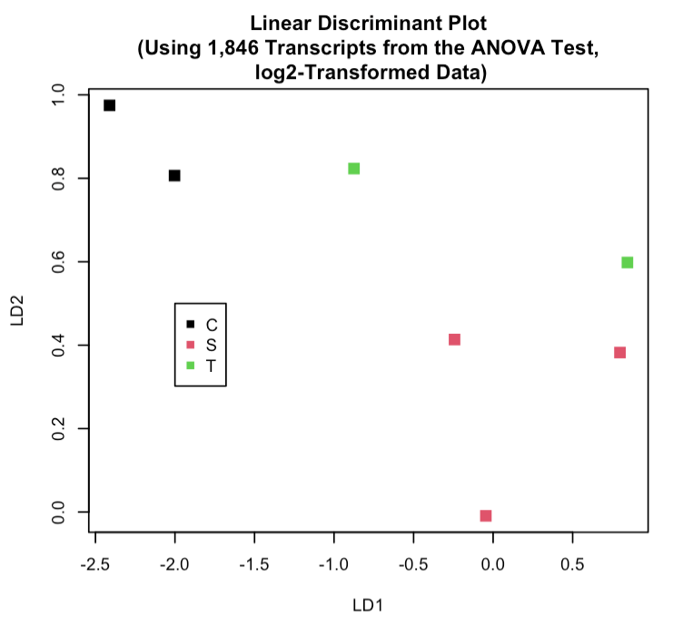

Conclusion: 2 samples from test set were classified incorrectly.

**#Subset Data with Genes from the Holm Test(20).**

datout.log.No.NA.Holm <- datout.log.No.NA[rownames(pvH),]

dim(datout.log.No.NA.Holm)

[1] 20 23

View(datout.log.No.NA.Holm)

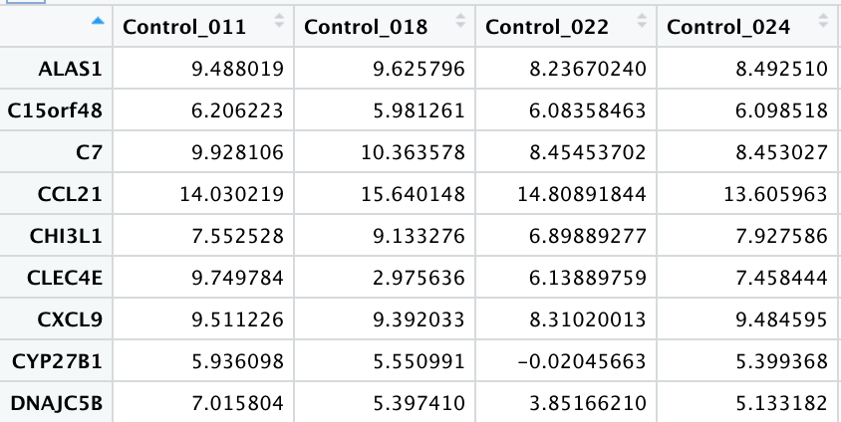

groupsH <- factor(substr(names(datout.log.No.NA.Holm),1,1))

d.groupsH <- data.frame(groupsH,t(datout.log.No.NA.Holm))

View(d.groupsH)

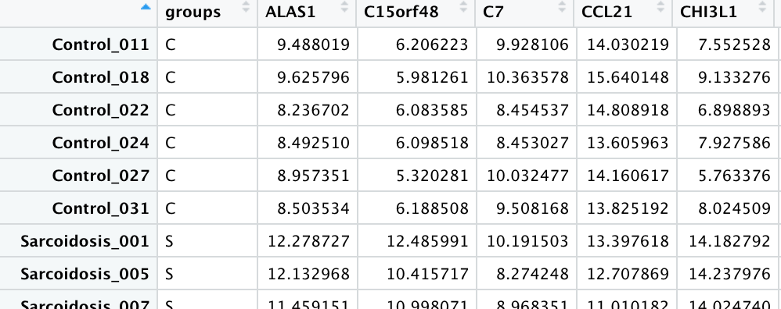

train <- d.groupsH[c(1:4,7:13,17:21),]

test <- d.groupsH[c(5:6,14:16,22:23),]

labs <- test[,1]

test <- test[,-1]

lda.train <- lda(groups ~ ., data=train)

lda.test <- predict(lda.train,test)

table(lda.test$class,labs)

labs

Co Sa TB

Co **2**  0 0

Sa 0 **3**  0

TB 0 0 **2**

**par**(oma=c(1,1,1,1))

plot(lda.test$x,col=as.numeric(labs),cex=1.5,pch=15,main="Linear Discriminant Plot\n(Using 20 Transcripts from the Holm Test,\n log2-Transformed Data)", ylab="LD2", xlab="LD1")

legend(-5.0,-0.5,pch=15,col= unique(as.numeric(labs)), unique(as.character(labs)))

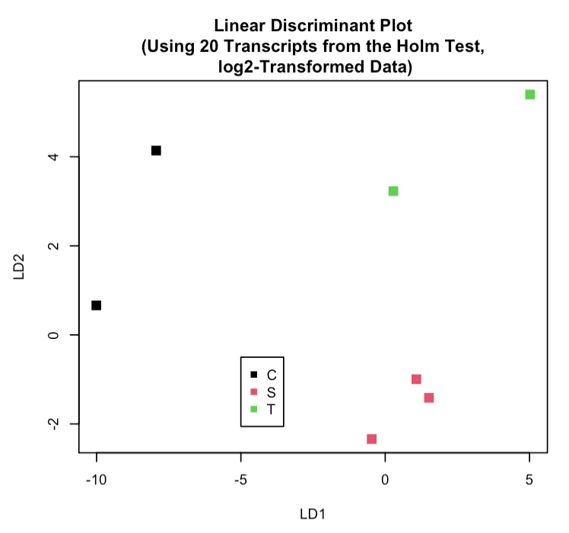Test sample set was classified correctly.

**#Support vector machine algorithm (SVM)**

library(kernlab)

datout.log.No.NA.Holm <- datout.log.No.NA[rownames(pvH),]

View(datout.log.No.NA.Holm)

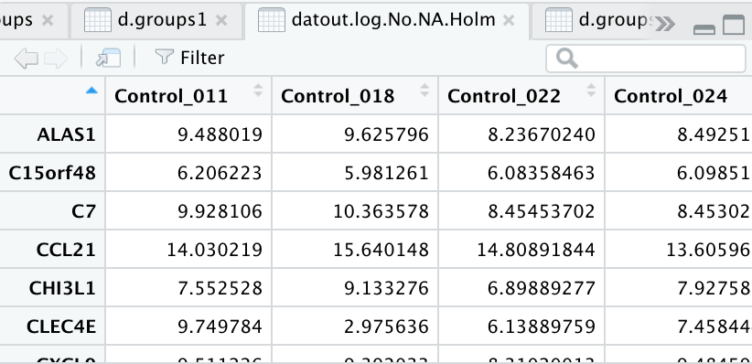

groupsH <- factor(substr(names(datout.log.No.NA.Holm),1,1))

d.groupsH <- data.frame(groupsH,t(datout.log.No.NA.Holm))

View(d.groupsH)

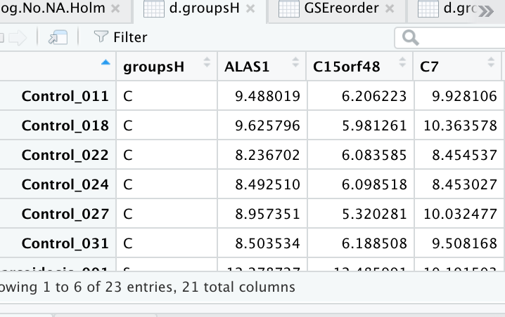

dat.f.sub.H <- pvH[rownames(pvH),]

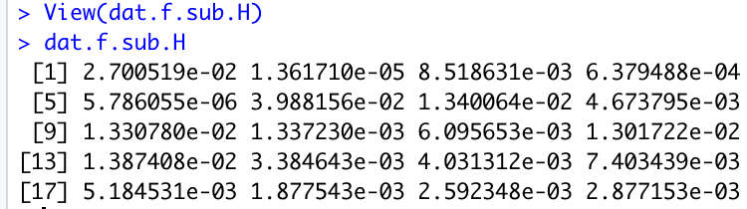

svp <- ksvm(t(datout.log.No.NA.Holm), d.groupsH$groupsH, type="C-svc")

svp

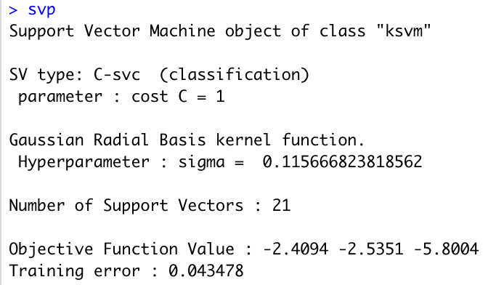

fit <- fitted(svp)

**par**(oma=c(0.2,0.1,0.2,0.1), xpd=NA)

plot(svp@coef[[1]], type="n", ylab="Coefficient*data", xlab="", axes=F, main="SVM using Holm-adjusted dataset")

text(c(1:23), svp@coef[[1]], fit, col=as.numeric(factor(fit)))

axis(2)

axis(1, at=c(1:23),labels=dimnames(d.groupsH)[[1]], cex.axis=1.0, las=3, cex=0.3)

table(d.groupsH$groupsH, fit)

> table(d.groupsH$groupsH, fit)

fit

C S T

C **6** 0 0

S 0 **10** 0

T 0 1 **6**

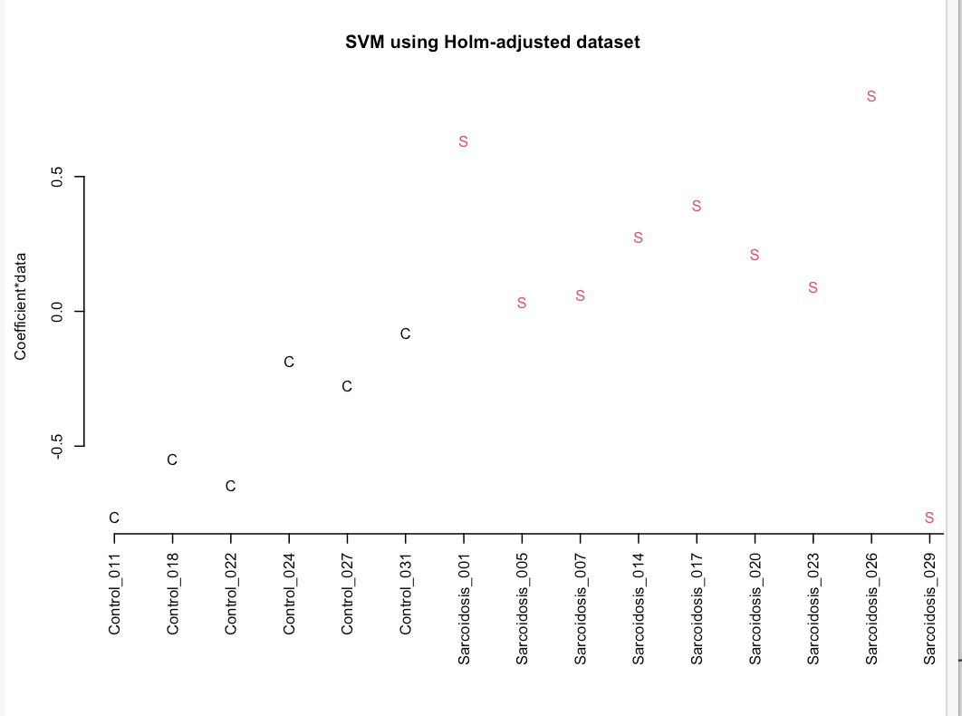 one test sample got misclassified.

#Select Differentially Expressed Transcripts from Filtered DATA (10,331 Significantly Expressed Genes)

**# Calculate the Fold Change Between the Groups (data are already on a log2 scale).**

foldCvsSC <- apply((datout.log.No.NA[,c(1:6)]),1,mean) - apply((datout.log.No.NA [,c(7:16)]),1,mean)

summary(foldCvsSC)

Min. 1st Qu. Median Mean 3rd Qu. Max.

-6.6335 -0.1797 0.2553 0.1954 0.6534 7.2298

foldCvsTB <- apply((datout.log.No.NA[,c(1:6)]),1,mean) - apply((datout.log.No.NA [,c(17:23)]),1,mean)

summary(foldCvsTB)

Min. 1st Qu. Median Mean 3rd Qu. Max.

-6.3287 0.2447 0.7672 0.7375 1.2672 6.4738

foldSCvsTB <- apply((datout.log.No.NA[,c(7:16)]),1,mean) - apply((datout.log.No.NA [,c(17:23)]),1,mean)

summary(foldSCvsTB)

Min. 1st Qu. Median Mean 3rd Qu. Max.

-6.1012 0.1959 0.5261 0.5421 0.8616 5.8939

**#Groups Control vs Sarcoidosis, 10,331 genes.**

**#Student's t-test (Group C vs SC)**

t.test.all.genes <- function(x,s1,s2) {

x1 <- x[s1]

x2 <- x[s2]

x1 <- as.numeric(x1)

x2 <- as.numeric(x2)

t.out <- t.test(x1,x2, alternative="two.sided", var.equal=T)

out <- as.numeric(t.out$p.value)

return(out) }

t.test.runCvsSC <- apply(datout.log.No.NA,1,t.test.all.genes,s1=c(1:6),s2=c(7:16))

**#Transform pvs**

p.transCvsSC <- -1 * log10(t.test.runCvsSC)

**#Volcano Plot for Groups C vs SC**

**#p-value=0.05**

x.line <- -log10(.05)

**#Fold change cut off =2**

y.line <- log2(4)

plot(range(p.transCvsSC),range(foldCvsSC),type="n", xlab=expression(paste("-",log[10],"(p-value)")), ylab=expression(paste(log[2],"fold change")), main="Volcano Plot for Groups: Control vs Sarcoidosis")

points(p.transCvsSC,foldCvsSC,col="black",pch=16)

points(p.transCvsSC[(p.transCvsSC>x.line&foldCvsSC>y.line)], foldCvsSC[(p.transCvsSC>x.line&foldCvsSC>y.line)],col=1,pch=21,bg=**'**red**'**)

points(p.transCvsSC[(p.transCvsSC >x.line&foldCvsSC<(-1*y.line))], foldCvsSC[(p.transCvsSC>x.line&foldCvsSC< (-1*y.line))], col=1, pch=21, bg='green')

abline(v=x.line)

abline(h=y.line)

abline(h=(-1*y.line))

text(p.transCvsSC [(p.transCvsSC >x.line&foldCvsSC>y.line)], foldCvsSC[(p.transCvsSC >x.line&foldCvsSC>y.line)], col='red',label=dimnames(datout.log.No.NA)[[1]][(p.transCvsSC >x.line&foldCvsSC>y.line)], cex=0.3)

text(p.transCvsSC [(p.transCvsSC >x.line&foldCvsSC<(-1*y.line))], foldCvsSC[(p.transCvsSC >x.line&foldCvsSC<(-1*y.line))], col='green',label=dimnames(datout.log.No.NA)[[1]][(p.transCvsSC >x.line&foldCvsSC<(-1*y.line))], cex=0.3)



probesCvsSC <- dimnames(datout.log.No.NA[(t.test.runCvsSC <(.05/10331) & abs(foldCvsSC)>log2(4)),])[[1]]

summary(probesCvsSC)  
Length Class Mode

31 character character

cbind(t.test.runCvsSC[probesCvsSC], foldCvsSC[probesCvsSC])

[,1] [,2]

ADAMDEC1 1.995667e-06 -2.970779

ALAS1 2.682151e-06 -2.620558

ATP6V1B2 3.064140e-06 -2.299304

C15orf48 1.943733e-09 -5.648423

CAPG 1.455742e-06 -2.765726

CHI3L1 6.504628e-10 -6.633524

CLEC7A 1.131246e-06 -4.127716

CTSB 1.510108e-06 -2.285517

CTSZ 1.640562e-06 -2.136761

DNAJC5B 6.914977e-07 -4.653297

FCER1G 1.184003e-06 -2.456877

FCGR2A 1.972683e-06 -3.613768

FTH1 7.874777e-07 -3.202373

FTH1P10 4.590626e-06 -2.838834

FTH1P11 2.851928e-06 -3.131324

FTH1P2 2.349724e-08 -2.923592

FTH1P21 4.048606e-06 -3.514155

FTH1P23 2.908397e-07 -3.339674

HLA-DQB2 8.188807e-09 -3.725602

IFI27 1.390034e-06 -2.375212

LPCAT2 9.902832e-07 -2.979450

MYOF 4.162601e-06 -3.323409

NUPR1 5.814264e-07 -3.780972

PGD 4.101183e-06 -2.389976

SCPEP1 1.031069e-06 -2.390965

SLAMF7 9.278260e-08 -2.510986

SNX10 9.197458e-08 -3.190226

TFEC 1.447131e-06 -2.711974

TFRC 1.458967e-06 -2.405256

TLR8 2.794675e-07 -3.524701

TYROBP 3.803220e-06 -2.383775

**#Group SC vs TB (10,331 Significantly Expressed transcripts).**

**#Student's t-test (Group C vs TB)**

t.test.all.genes <- function(x,s1,s2) {

x1 <- x[s1]

x2 <- x[s2]

x1 <- as.numeric(x1)

x2 <- as.numeric(x2)

t.out <- t.test(x1,x2, alternative="two.sided", var.equal=T)

out <- as.numeric(t.out$p.value)

return(out) }

t.test.runSCvsTB <- apply(datout.log.No.NA,1,t.test.all.genes,s1=c(7:16),s2=c(17:23))

**#Transform pvs**

p.transSCvsTB <- -1 * log10(t.test.runSCvsTB)

**#Volcano Plot for Groups SC vs TB**

**#p-value=0.05**

x.line <- -log10(.05)

**#fold change cut off =2**

y.line <- log2(4)

plot(range(p.transSCvsTB),range(foldSCvsTB),type="n", xlab=expression(paste("-",log[10],"(p-value)")), ylab=expression(paste(log[2],"fold change")), main="Volcano Plot for Groups: Sarcoidosis vs Tuberculosis")

points(p.transSCvsTB,foldSCvsTB,col="black",pch=16)

points(p.transSCvsTB[(p.transSCvsTB>x.line&foldSCvsTB>y.line)], foldSCvsTB[(p.transSCvsTB>x.line&foldSCvsTB>y.line)],col=1,pch=21,bg=**'**red**'**)

points(p.transSCvsTB[(p.transSCvsTB >x.line&foldSCvsTB<(-1*y.line))], foldSCvsTB[(p.transSCvsTB>x.line&foldSCvsTB< (-1*y.line))], col=1, pch=21, bg='green')

abline(v=x.line)

abline(h=y.line)

abline(h=(-1*y.line))

text(p.transSCvsTB [(p.transSCvsTB >x.line&foldSCvsTB>y.line)], foldSCvsTB[(p.transSCvsTB >x.line&foldSCvsTB>y.line)], col='red',label=dimnames(datout.log.No.NA)[[1]][(p.transSCvsTB >x.line&foldSCvsTB>y.line)], cex=0.3)

text(p.transSCvsTB [(p.transSCvsTB >x.line&foldSCvsTB<(-1*y.line))], foldSCvsTB[(p.transSCvsTB >x.line&foldSCvsTB<(-1*y.line))], col='green',label=dimnames(datout.log.No.NA)[[1]][(p.transSCvsTB >x.line&foldSCvsTB<(-1*y.line))], cex=0.3)



probesSCvsTB <- dimnames(datout.log.No.NA[(t.test.runSCvsTB <(.05/10331) & abs(foldSCvsTB)>log2(4)),])[[1]]

summary(probesSCvsTB)  
Length Class Mode

0 character character

cbind(t.test.runSCvsTB[probesSCvsTB], foldSCvsTB[probesSCvsTB])

[,1] [,2]

(you should get 69-genes column)

**#Identify DEG in Data Subset from the Holm Test (20 transcripts).**

**# Calculate the Fold Change Between the Groups.**

**#Subset Data With Genes from the Holm Test**

datout.log.No.NA.Holm <- datout.log.No.NA[rownames(pvH),]

datout.log.No.NA.Holm

dim(datout.log.No.NA.Holm)

foldCvsSC <- apply((datout.log.No.NA.Holm[,c(1:6)]),1,mean) - apply((datout.log.No.NA.Holm[,c(7:16)]),1,mean)

summary(foldCvsSC)

Min. 1st Qu. Median Mean 3rd Qu. Max.

-6.634 -3.874 -3.230 -2.983 -2.689 2.236

foldCvsTB <- apply((datout.log.No.NA.Holm [,c(1:6)]),1,mean) - apply((datout.log.No.NA.Holm [,c(17:23)]),1,mean)

summary(foldCvsTB)

Min. 1st Qu. Median Mean 3rd Qu. Max.

-6.175 -3.693 -3.046 -2.404 -2.552 5.067

foldSCvsTB <- apply((datout.log.No.NA.Holm [,c(7:16)]),1,mean) - apply((datout.log.No.NA.Holm [,c(17:23)]),1,mean)

summary(foldSCvsTB)

**#Group C vs SC (from Holm Test)**

**#Student's t-test (Group C vs SC) and Volcano Plot**

t.test.all.genes <- function(x,s1,s2) {

x1 <- x[s1]

x2 <- x[s2]

x1 <- as.numeric(x1)

x2 <- as.numeric(x2)

t.out <- t.test(x1,x2, alternative="two.sided", var.equal=T)

out <- as.numeric(t.out$p.value)

return(out) }

t.test.runCvsSC <- apply(datout.log.No.NA.Holm,1,t.test.all.genes,s1=c(1:6),s2=c(7:16))

**#Transform pvs**

p.transCvsSC <- -1 * log10(t.test.runCvsSC)

**#Volcano Plot for Groups C vs SC**

**#p-value=0.05**

x.line <- -log10(.05)

**#log fold change comparaison >2, C vs SC**

y.line <- log2(4)

plot(range(p.transCvsSC),range(foldCvsSC),type="n", xlab=expression(paste("-",log[10],"(p-value)")), ylab=expression(paste(log[2],"fold change")), main="Volcano Plot for Groups: Control vs Sarcoidosis\n 20 Transcripts from the Holm Test")

points(p.transCvsSC,foldCvsSC, col="black",pch=16)

points(p.transCvsSC[(p.transCvsSC>x.line&foldCvsSC>y.line)], foldCvsSC[(p.transCvsSC>x.line&foldCvsSC>y.line)],col=1,pch=21,bg=**'**red**'**)

points(p.transCvsSC[(p.transCvsSC >x.line&foldCvsSC<(-1*y.line))], foldCvsSC[(p.transCvsSC>x.line&foldCvsSC< (-1*y.line))], col=1, pch=21, bg='green')

abline(v=x.line)

abline(h=y.line)

abline(h=(-1*y.line))

text(p.transCvsSC [(p.transCvsSC >x.line&foldCvsSC>y.line)], foldCvsSC[(p.transCvsSC >x.line&foldCvsSC>y.line)], col='red',label=dimnames(datout.log.No.NA.Holm)[[1]][(p.transCvsSC >x.line&foldCvsSC>y.line)], cex=0.8)

text(p.transCvsSC [(p.transCvsSC >x.line&foldCvsSC<(-1*y.line))], foldCvsSC[(p.transCvsSC >x.line&foldCvsSC<(-1*y.line))], col='green',label=dimnames(datout.log.No.NA.Holm)[[1]][(p.transCvsSC >x.line&foldCvsSC<(-1*y.line))], cex=0.8)



probesCvsSC <- dimnames(datout.log.No.NA.Holm [(t.test.runCvsSC <(.05/20) & abs(foldCvsSC)>log2(4)),])[[1]]

summary(probesCvsSC)

Length Class Mode

18 character character

cbind(t.test.runCvsSC[probesCvsSC], foldCvsSC[probesCvsSC])

[,1] [,2]

ALAS1 2.682151e-06 -2.620558

C15orf48 1.943733e-09 -5.648423

CHI3L1 6.504628e-10 -6.633524

CLEC4E 3.799928e-05 -4.698049

CXCL9 1.784240e-05 -3.257872

CYP27B1 1.026112e-05 -5.868966

DNAJC5B 6.914977e-07 -4.653297

DSP 5.272044e-05 2.236074

FCGR2A 1.972683e-06 -3.613768

FTH1 7.874777e-07 -3.202373

FTH1P11 2.851928e-06 -3.131324

FTH1P2 2.349724e-08 -2.923592

FTH1P23 2.908397e-07 -3.339674

GBP1 6.899795e-06 -2.389508

MYOF 4.162601e-06 -3.323409

SNX10 9.197458e-08 -3.190226

TFEC 1.447131e-06 -2.711974

TLR8 2.794675e-07 -3.524701

**#** **# DEG Group C vs TB (from Holm Test)**

**#Student's t-test (Group C vs TB) and Volcano Plot**

t.test.all.genes <- function(x,s1,s2) {

x1 <- x[s1]

x2 <- x[s2]

x1 <- as.numeric(x1)

x2 <- as.numeric(x2)

t.out <- t.test(x1,x2, alternative="two.sided", var.equal=T)

out <- as.numeric(t.out$p.value)

return(out) }

t.test.runCvsTB <- apply(datout.log.No.NA.Holm,1,t.test.all.genes,s1=c(1:6),s2=c(17:23))

**#Transform pvs**

p.transCvsTB <- -1 * log10(t.test.runCvsTB)

**#Volcano Plot for Groups C vs TB**

**#p-value=0.05**

x.line <- -log10(.05)

**#fold change cut off =2**

y.line <- log2(4)

plot(range(p.transCvsTB),range(foldCvsTB),type="n", xlab=expression(paste("-",log[10],"(p-value)")), ylab=expression(paste(log[2],"fold change")), main="Volcano Plot for Groups: Control vs Tuberculosis\n 20 Transcripts from the Holm Test")

points(p.transCvsTB,foldCvsTB, col="black",pch=16)

points(p.transCvsTB[(p.transCvsTB>x.line&foldCvsTB>y.line)], foldCvsTB[(p.transCvsTB>x.line&foldCvsTB>y.line)],col=1,pch=21,bg=**'**red**'**)

points(p.transCvsTB[(p.transCvsTB >x.line&foldCvsTB<(-1*y.line))], foldCvsTB[(p.transCvsTB>x.line&foldCvsTB< (-1*y.line))], col=1, pch=21, bg='green')

abline(v=x.line)

abline(h=y.line)

abline(h=(-1*y.line))

text(p.transCvsTB [(p.transCvsTB >x.line&foldCvsTB>y.line)], foldCvsTB[(p.transCvsTB >x.line&foldCvsTB>y.line)], col='red',label=dimnames(datout.log.No.NA.Holm)[[1]][(p.transCvsTB >x.line&foldCvsTB>y.line)], cex=0.8)

text(p.transCvsTB [(p.transCvsTB >x.line&foldCvsTB<(-1*y.line))], foldCvsTB[(p.transCvsTB >x.line&foldCvsTB<(-1*y.line))], col='green',label=dimnames(datout.log.No.NA.Holm)[[1]][(p.transCvsTB >x.line&foldCvsTB<(-1*y.line))], cex=0.8)



probesCvsTB <- dimnames(datout.log.No.NA.Holm[(t.test.runCvsTB <(.05/20) & abs(foldCvsTB)>log2(4)),])[[1]]

summary(probesCvsTB)  
Length Class Mode

20 character character

cbind(t.test.runCvsTB[probesCvsTB], foldCvsTB[probesCvsTB])

ALAS1 2.747376e-04 -2.060521

C15orf48 1.009456e-06 -6.010223

C7 3.599599e-05 4.183338

CCL21 4.800004e-06 5.066724

CHI3L1 1.237486e-05 -5.509020

CLEC4E 7.666812e-04 -4.450430

CXCL9 1.276823e-05 -4.173201

CYP27B1 5.428212e-05 -6.175469

DNAJC5B 1.153625e-03 -3.328349

DSP 5.690382e-06 3.897188

FCGR2A 7.118997e-05 -3.390011

FTH1 1.521722e-04 -2.648333

FTH1P11 1.164838e-04 -2.573746

FTH1P2 2.415613e-04 -2.486179

FTH1P23 1.277927e-04 -2.719947

GBP1 1.352982e-05 -3.532579

MYOF 3.009921e-06 -3.395993

SNX10 1.980435e-05 -3.282646

TFEC 6.314291e-05 -2.675928

TLR8 4.474801e-05 -2.809198

**##Select Differentially Expressed Transcripts from Data Subset = 1,846 transcripts from the ANOVA Test.**

**# Calculate the Fold Change Between the Groups.**

**#Subset Data with Genes that Have P-value < 0.05 from ANOVA**

datout.log.No.NA.subA <- datout.log.No.NA[rownames(pvA),]

dim(datout.log.No.NA.subA)

[1] 1846 23

foldCvsSCa <- apply((datout.log.No.NA.subA [,c(1:6)]),1,mean) - apply((datout.log.No.NA.subA [,c(7:16)]),1,mean)

summary(foldCvsSCa)

Min. 1st Qu. Median Mean 3rd Qu. Max.

-6.6335 -0.5814 0.5541 0.1300 0.9862 4.7626

foldCvsTBa <- apply((datout.log.No.NA.subA [,c(1:6)]),1,mean) - apply((datout.log.No.NA.subA [,c(17:23)]),1,mean)

summary(foldCvsTBa)

Min. 1st Qu. Median Mean 3rd Qu. Max.

-6.1755 0.7366 1.4060 1.0515 1.9422 6.4738

foldSCvsTBa <- apply((datout.log.No.NA.subA [,c(7:16)]),1,mean) - apply((datout.log.No.NA.subA [,c(17:23)]),1,mean)

summary(foldSCvsTBa)

Min. 1st Qu. Median Mean 3rd Qu. Max.

-3.0265 0.5519 0.8633 0.9216 1.2527 5.8200

**#Group comparison C vs SC (1,846 transcripts)**

**#Student's t-test (Group C vs SC) and Volcano Plot.**

t.test.all.genes <- function(x,s1,s2) {

x1 <- x[s1]

x2 <- x[s2]

x1 <- as.numeric(x1)

x2 <- as.numeric(x2)

t.out <- t.test(x1,x2, alternative="two.sided", var.equal=T)

out <- as.numeric(t.out$p.value)

return(out) }

t.test.runCvsSCa <- apply(datout.log.No.NA.subA,1,t.test.all.genes,s1=c(1:6),s2=c(7:16))

**#Transform pvs**

p.transCvsSCa <- -1 * log10(t.test.runCvsSCa)

**#Volcano Plot for Groups C vs SC**

**#p-value=0.05**

x.line <- -log10(.05)

**#fold change=2**

y.line <- log2(4)

plot(range(p.transCvsSCa),range(foldCvsSCa),type="n", xlab=expression(paste("-",log[10],"(p-value)")), ylab=expression(paste(log[2],"fold change")), main="Volcano Plot for Groups: Control vs Sarcoidosis\n 1,846 Transcripts from the ANOVA Test")

points(p.transCvsSCa,foldCvsSCa, col="black",pch=16)

points(p.transCvsSCa[(p.transCvsSCa>x.line&foldCvsSCa>y.line)], foldCvsSCa[(p.transCvsSCa>x.line&foldCvsSCa>y.line)],col=1,pch=21,bg=**'**red**'**)

points(p.transCvsSCa[(p.transCvsSCa >x.line&foldCvsSCa<(-1*y.line))], foldCvsSCa[(p.transCvsSCa>x.line&foldCvsSCa< (-1*y.line))], col=1, pch=21, bg='green')

abline(v=x.line)

abline(h=y.line)

abline(h=(-1*y.line))

text(p.transCvsSCa [(p.transCvsSCa >x.line&foldCvsSCa>y.line)], foldCvsSCa[(p.transCvsSCa >x.line&foldCvsSCa>y.line)], col='red',label=dimnames(datout.log.No.NA.subA)[[1]][(p.transCvsSCa >x.line&foldCvsSCa>y.line)], cex=0.8)

text(p.transCvsSCa [(p.transCvsSCa >x.line&foldCvsSCa<(-1*y.line))], foldCvsSCa[(p.transCvsSCa >x.line&foldCvsSCa<(-1*y.line))], col='green',label=dimnames(datout.log.No.NA.subA)[[1]][(p.transCvsSCa >x.line&foldCvsSCa<(-1*y.line))], cex=0.8)



probesCvsSCa <- dimnames(datout.log.No.NA.subA [(t.test.runCvsSCa <(.05/1846) & abs(foldCvsSCa)>log2(4)),])[[1]]

summary(probesCvsSCa)  
Length Class Mode

68 character character

cbind(t.test.runCvsSCa[probesCvsSCa], foldCvsSCa[probesCvsSCa])

[,1] [,2]

ABCA8 1.718201e-05 3.116552

ACO1 1.877782e-05 -2.304259

ADAMDEC1 1.995667e-06 -2.970779

AK4 1.728302e-05 -3.730563

ALAS1 2.682151e-06 -2.620558

ATP6V1B2 3.064140e-06 -2.299304

C15orf48 1.943733e-09 -5.648423

C1QB 1.243881e-05 -2.333185

CAPG 1.455742e-06 -2.765726

CD68 9.937159e-06 -2.074532

CHI3L1 6.504628e-10 -6.633524

CLEC7A 1.131246e-06 -4.127716

CTSB 1.510108e-06 -2.285517

CTSD 2.306033e-05 -2.102741

CTSZ 1.640562e-06 -2.136761

CXCL16 1.874852e-05 -2.836073

CXCL9 1.784240e-05 -3.257872

CYP27B1 1.026112e-05 -5.868966

DNAJC5B 6.914977e-07 -4.653297

DOCK4 9.785807e-06 -2.731029

DRAM1 2.416273e-05 -2.498420

FCER1G 1.184003e-06 -2.456877

FCGR2A 1.972683e-06 -3.613768

FTH1 7.874777e-07 -3.202373

FTH1P10 4.590626e-06 -2.838834

FTH1P11 2.851928e-06 -3.131324

FTH1P16 2.443195e-05 -3.408279

FTH1P2 2.349724e-08 -2.923592

FTH1P21 4.048606e-06 -3.514155

FTH1P23 2.908397e-07 -3.339674

GBP1 6.899795e-06 -2.389508

GNS 6.694482e-06 -2.072059

HEXB 1.371907e-05 -2.374707

HLA-DQB2 8.188807e-09 -3.725602

HTRA4 1.381300e-05 -3.784227

IFI27 1.390034e-06 -2.375212

ITGB5 1.617719e-05 -2.877775

LILRB3 4.857033e-06 -3.536005

LPCAT2 9.902832e-07 -2.979450

LYZ 1.965911e-05 -2.962790

MCTP1 1.657141e-05 -2.403003

MMP14 2.158014e-05 -2.544764

MOSPD1 8.364913e-06 -2.155091

MREG 1.215367e-05 -2.790176

MYOF 4.162601e-06 -3.323409

NCF2 9.174493e-06 -2.748483

NR1H3 1.021327e-05 -2.011003

NRIP3 1.588936e-05 -3.417022

NUPR1 5.814264e-07 -3.780972

PGD 4.101183e-06 -2.389976

PLA2G7 6.685064e-06 -2.631595

PLAU 1.884722e-05 -3.149676

PLBD1 8.779794e-06 -3.288518

PLXDC2 1.702212e-05 -2.899976

PTAFR 1.656208e-05 -2.761481

SCPEP1 1.031069e-06 -2.390965

SIRPA 1.620093e-05 -2.340678

SLAMF7 9.278260e-08 -2.510986

SLC1A3 1.180835e-05 -2.916421

SNX10 9.197458e-08 -3.190226

SOD2 9.488609e-06 -2.248187

STEAP3 1.018094e-05 -3.944244

TFEC 1.447131e-06 -2.711974

TFRC 1.458967e-06 -2.405256

TLR8 2.794675e-07 -3.524701

TYROBP 3.803220e-06 -2.383775

UBE2D1 7.980097e-06 -2.075839

WARS 1.529053e-05 -2.104042

**#Group comparison C vs TB (1,846 transcripts).**

**#Student's t-test (Group C vs TB)**

t.test.all.genes <- function(x,s1,s2) {

x1 <- x[s1]

x2 <- x[s2]

x1 <- as.numeric(x1)

x2 <- as.numeric(x2)

t.out <- t.test(x1,x2, alternative="two.sided", var.equal=T)

out <- as.numeric(t.out$p.value)

return(out) }

t.test.runCvsTBa <- apply(datout.log.No.NA.subA,1,t.test.all.genes,s1=c(1:6),s2=c(17:23))

**#Transform pvs**

p.transCvsTBa <- -1 * log10(t.test.runCvsTBa)

**#Volcano Plot for Groups C vs SC**

**#p-value=0.05**

x.line <- -log10(.05)

**#fold change=2**

y.line <- log2(4)

plot(range(p.transCvsTBa),range(foldCvsTBa),type="n", xlab=expression(paste("-",log[10],"(p-value)")), ylab=expression(paste(log[2],"fold change")), main="Volcano Plot for Groups: Control vs Tuberculosis\n 1,846 Transcripts from the ANOVA Test")

points(p.transCvsTBa,foldCvsTBa, col="black",pch=16)

points(p.transCvsTBa[(p.transCvsTBa>x.line&foldCvsTBa>y.line)], foldCvsTBa[(p.transCvsTBa>x.line&foldCvsTBa>y.line)],col=1,pch=21,bg=**'**red**'**)

points(p.transCvsTBa[(p.transCvsTBa >x.line&foldCvsTBa<(-1*y.line))], foldCvsTBa[(p.transCvsTBa>x.line&foldCvsTBa< (-1*y.line))], col=1, pch=21, bg='green')

abline(v=x.line)

abline(h=y.line)

abline(h=(-1*y.line))

text(p.transCvsTBa [(p.transCvsTBa >x.line&foldCvsTBa>y.line)], foldCvsTBa[(p.transCvsTBa >x.line&foldCvsTBa>y.line)], col='red',label=dimnames(datout.log.No.NA.subA)[[1]][(p.transCvsTBa >x.line&foldCvsTBa>y.line)], cex=0.8)

text(p.transCvsTBa [(p.transCvsTBa >x.line&foldCvsTBa<(-1*y.line))], foldCvsTBa[(p.transCvsTBa >x.line&foldCvsTBa<(-1*y.line))], col='green',label=dimnames(datout.log.No.NA.subA)[[1]][(p.transCvsTBa >x.line&foldCvsTBa<(-1*y.line))], cex=0.8)



probesCvsTBa <- dimnames(datout.log.No.NA.subA [(t.test.runCvsTBa <(.05/1846) & abs(foldCvsTBa)>log2(4)),])[[1]]

summary(probesCvsTBa)  
 Length Class Mode

12 character character

cbind(t.test.runCvsTBa[probesCvsTBa], foldCvsTBa[probesCvsTBa])

[,1] [,2]

ADH1B 7.697494e-07 6.473826

C15orf48 1.009456e-06 -6.010223

CCL21 4.800004e-06 5.066724

CHI3L1 1.237486e-05 -5.509020

CXCL9 1.276823e-05 -4.173201

DSP 5.690382e-06 3.897188

FCMR 1.498026e-05 4.077411

GBP1 1.352982e-05 -3.532579

MATN2 1.839001e-05 3.136921

MYOF 3.009921e-06 -3.395993

SNX10 1.980435e-05 -3.282646

SYT15 6.986989e-06 4.363464

Using the top 5 discriminant gene names (positive and negative direction) and functional information (NCBI’s DAVID associated pathways, GO terms) for top 10 genes.



See presentation.